Desktop Keyboard
Feel-good typing that's built to go the distance

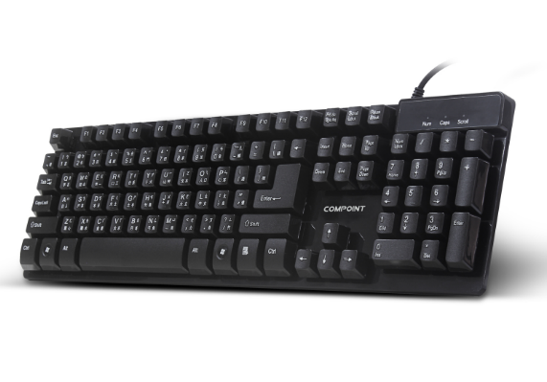

Descrption:

Looking to improve your typing experience with a more positive mechanical feel experience but don't want the expense of a full mechanical keyboard?

The exciting CP-K5100 mechanical feel keyboard gives you a rewarding typing experience with every keystroke, similar to the expensive full mechanical keyboard, but without the high-price tag.

Enjoy a faster, more purposeful typing experience, ideal not just for business applications, but ideal for leisure and gamer's too with more accurate game-play. Supplied with a hard wearing, extra-long USB cable (175cm approx.) means its also ideal for floor standing PCs project computers and media centres.

Features:

Mechanically Similar Typing Experience

Solid Metal Base - Keeping Your Keyboard In Place

Tactile Keystrokes - Faster And Rewarding Typing

Woven, Extended USB Cabling - Interference Free

Plug N' Play For WindowsTM, MacTM, LinuxTM etc

Specifications
- material :ABS material
- Port：USB
- Cable: 1.5M lenght
- Low-profile, quiet keys
- Full-size keyboard
- Thin-profile keyboard
- Spill-resistant design
- Durable keys that can last
- up to 10 million keystrokes
- Strong, adjustable tilt legs
- Plug-and-play USB connection
- Bold, bright characters
- No software installation
- Certificate: CE FCC ROHS
- Operating Temperature:0℃ to +45℃
- Operating Humidity:10%0 to 85 % RH
- Storage Temperature : -10℃ to +55℃
- Storage Humidity: 5% to 90 % RH

Product Code:
Part number: K5100
Barcode: 8400800034571
Size: 439*126*23mm
Weight: 0.430 kg

